**Table overview power simulations**

|  |  |  |  |
| --- | --- | --- | --- |
| **Function name** | **description** | **called by** | **methods** |
|  |  |  |  |
| buildSimModel | Builds input for lavaan | simPwr.growth |  |
| simPwr.growth | latent growth model with k measurements, one mediation effect and one interaction effect, for a given N, and given ES | simPwr.lgm | print |
| simPwr.lgm | power curves of a latent growth model with k measurements, one mediation effect and one interaction effect, for varying N and varying ES |  | Plot in wording |
|  |  |  |  |
| drawSamples | estimate the power in an linear model with interaction effects | simPwr.regr |  |
| simPwr.regr | wrapper around drawSamples, for given N | simPwr.mod | print |
| simPwr.mod | Wrapper around simPwr.regr for varying N |  | print  plot |
|  |  |  |  |

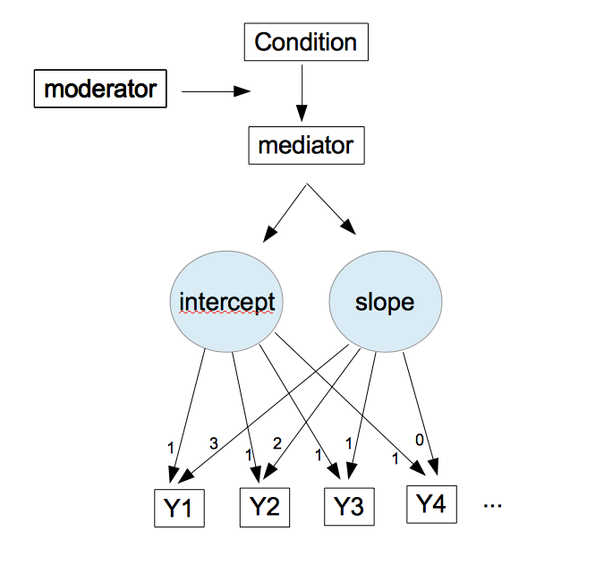

Figure 1. Latent growth model with moderated mediation. Fit by functions simPwr.lgm and simPwr.growth.

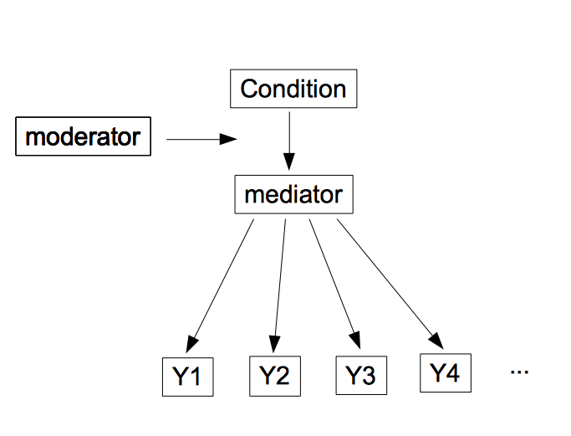

Figure 2. Moderated mediation repeated measures model. Fit by function simPwr.mmrm.